A Robust Multi-Class Age Detection Framework Using EfficientNetB3 Feature Transfer and Optimized Classification Head

Gargi P. Lad¹, Abhijeet R. Raipurkar¹

¹ Ramdeobaba University, Katol Road, Nagpur-440013
ladgp@rknec.edu, raipurkarar@rknec.edu

Abstract: The Age classification is a critical task in computer vision with widespread applications in fields such as healthcare, security, and autonomous systems. This project presents a deep learning approach for multi-class image classification using feature extraction with the EfficientNetB3 architecture. The model was trained on a dataset that has images labeled according to different age groups, where the images were preprocessed, normalized, and sized to a steady resolution appropriate for EfficientNetB3 input. Data handling was simplified using pandas and ImageDataGenerator, ensuring proper splitting into training, validation, and test sets, with suitable shuffling and augmentation strategies applied to improve generalization.

This model influences EfficientNetB3 as a feature extractor, combined with a custom classification head containing Batch Normalization, L1/L2 regularization with Dense layers, Dropout, and a SoftMax output layer. This model was trained using the Adamax optimizer and categorical cross-entropy loss, with performance monitored through accuracy and loss metrics over multiple epochs. Training history was seen to identify the epochs corresponding to the best validation performance.
Assessment of the model on the test data-set includes loss, accuracy, confusion matrix, and a comprehensive classification report with precision, recall, and F1-score for each set. The results demonstrate that transfer learning, combined with careful preprocessing and regularization, can achieve robust performance in image classification tasks. This pipeline provides a producible and scalable framework for multi-class image classification and can be extended to other datasets and real-world applications requiring automatic image recognition.

Keywords: Artificial Intelligence; Age Detection; Generative AI; Convolutional Neural Network; Deep Learning.

Introduction
Age estimation has occurred as an important factor in numerous real-world applications, with personalized digital services, security systems, healthcare analytics, and demographic studies. Traditional age estimation methods rely on handcrafted features, statistical modelling, which often struggle to cope with variations in pose, expressions, and diversity. Recent advances in deep learning have significantly improved age prediction accuracy. Nowadays advancements in deep learning have led to lot of improvements in age detection accuracy, effectively overcoming the limitations of traditional age estimation methods that struggled with variations in pose, expressions, and diversity.

In this project, a multi-class image classification system was created utilizing a deep learning pipeline built with TensorFlow and Keras. The objective was to build a Convolutional Neural Network (CNN) capable of accurately classifying images into predefined sets. We use transfer learning with the EfficientNetB3 architecture, which provides a balance of high accuracy and efficiency.

Model training involves categorical cross-entropy loss and the Adamax optimizer, selected for their effectiveness with sparce gradients and stable merging. Performance evaluation uses standard metrics such as accuracy, along with more detailed valuations like confusion matrices and classification reports. These reports offered class-specifics precision, recall, and F1-score, allowing for a thorough analysis of overall model performances as well as specific class strengths and weaknesses.

This project effectively developed a high-performance image classification model by integrating the strengths of transfer learning, robust preprocessing, and severe evaluation. The resulting approach efficiently balances measurable needs with predictable accuracy, establishing a reliable foundation for automated image recognition application. Furthermore, the methodology is flexible, as it can be broadly applied and adapted to diverse image datasets and classification tasks, showing the power of modern deep learning techniques in computer vision.

2. Literature Review

Facial recognition is, therefore, a crucial aspect of biometric systems used when authenticating as well as verifying people’s identity. But here natural aging increases several difficulties concerning accuracy and long-term reliability of the control systems [1]. The posture, vocabulary, facial wrinkles, and the intonation are all elements that facilitate the prediction of the user's age. Age estimation from the face by numerical analysis finds many potential applications such as the development of intelligent human-machine interfaces and improvement of safety and protection in various sectors such as transport, security and medicine[2]

The increasing GenAI technology is promising for applications in the visualization domain. Because of GenAI’s impressive capacity to model the transformation and design process by learning from real data, it can benefit a range of visualization tasks like data enhancement, visual mapping generation, stylization, and interaction. Different types of GenAI methods have been applied to these tasks due to different data structures, including sequence generation, tabular generation, spatial generation, and graph generation.[3]

The two parameters that are displayed are gender and age. For gender, male and female categorizations are done. And in the second parameter, a range of values for age. This application does not predict the birth year as it only classifies the age range, that is, (20-30 years), (30-40), (50-60), etc..[7]
Automatic age and gender detection from face images has lately attracted much attention because of its large range of applications in multiple facial analyses. This paper shows in this study that utilizing the Caffe Model Architecture of Deep Learning Frame Work greatly enhances age and gender recognition by learning representations using deep-convolutional neural networks.[8]

3. Project Definition
The objective of this project is to use deep learning to create a reliable and accurate multiclass image classification system. This system automatically classifies images into predefined categories by directly learning hierarchical visual features from raw image data. It maximizes accuracy while reducing computational costs and training time by utilizing transfer learning with EfficientNetB3 architecture.
Model training utilizes the Adamax optimizer and categorical cross-entropy loss, with performance continuously monitored on both training and validation datasets. After training, the system evaluates the model thoroughly on a different test set using metrics like loss, accuracy, precision, recall, F1-score, and confusion matrices.

4. Project Objective
This project's main objective is the use deep learning and transfer learning techniques to design and implement a highly accurate multi-class image classification system. The project's specific objectives are to:

4.1 Transfer Learning
To extract reliable and broadly applicable features from images, use the EfficientNetB3 architecture that has been pretrained on ImageNet.

4.2 Preprocess and Augment Data

To enhance model generalization, standardize image input sizes, normalize pixel values, and use data augmentation.

4.3 Develop a Custom Classification Head
To efficiently classify images into several categories, combine batch normalization, dropout, dense layers with regularization, and SoftMax output.

4.4 Train and Enhance the Model
While tracking the model's performance on training set and validation set, train it by using Adamax optimizer and categorical cross-entropy loss.

4.5 Evaluate Model Performance
To guarantee dependability across all classes, quantitatively assess the model by using metrics like accuracy, loss, confusion matrix, and classification report.

4.6 Provide a Reproducible Framework
Create a pipeline that is reproducible, scalable, and adaptable to different datasets and image classification tasks.

5. Proposed Work

5.1 Develop an End-to-End Multi-Class Image Classification System

Create an extensive deep learning pipeline that can classify images into multiple preestablished data sets.

To Ensure the system is flexible, adaptable, and appropriate for real-world applications requiring automated image recognition.

5.2 Implement a Structured Data Handling and Preparation Framework
Headings, or heads, are organizational devices that directs the reader through your paper:

Use directory-based class labels to load and arrange images.

For efficient processing, transform image paths and associated labels into structured pandas DataFrames.

Divide the dataset into training, validation, and testing sets to ensure unbiased evaluation.

Preprocess all images by resizing them to 224 × 224 resolution and normalizing pixel values

Use ImageDataGenerator to program image loading, batching, normalization, and optional augmentation.

Utilize a Pretrained Feature Extraction Model
- Because of its accuracy and computational efficiency, use EfficientNetB3 as the main feature extractor.
- To reuse its developed visual features, load EfficientNetB3 with pretrained ImageNet weights and disable its top layers.
- To transform multidimensional feature maps into compact vectors appropriate for classification, use global max pooling.

5.4 Design a Personalized Classification Head for Fine-Tuning

To improve training stability and accelerate convergence, implement batch normalization.

To reduce overfitting, add a Dense layer with 256 unit, enhanced with L1 L2 regularization.

Add a Dropout layer (0.4) to further improve generalization by avoiding neuron co-dependency.

To perform multi-class prediction, use a SoftMax output layer that matches the number of target classes.

5.5 Train the Model with Optimized Hyperparameters

Use the Adamax optimizer, which was selected for its stability with sparse gradients, to compile the entire model.

Use categorical cross-entropy as the loss function for multi-class classification.

Monitor the model's accuracy and loss during training and validation over a number of epochs.

Create plots to see learning behavior and identify the most effective training epoch.

5.6 Perform Robust Model Assessment

Assess the trained model using training, validation, and test datasets to measure generalization ability.

Calculate accuracy and loss scores for each split dataset.

Create a confusion matrix to visualize class-wise misclassifications and interpret model weaknesses.

Create a classification report with precision, recall, F1-score, and backing for each class.

Use predictions to analyze whether the model constantly performs well across all categories.

5.7 Use Regularization, Normalization, and Optimization Techniques

To prevent overfitting, use activity regularization, dropout, and kernel regularization (L1/L2).

To improve the model's robustness and manage internal covariate shift, apply batch normalization.

To ensure steady convergence, use an appropriate learning rate with Adamax.

5.8 Develop an Extensible and Reproducible Framework

Ensure that all pipeline steps, including data loading, training, evaluation, and visualization, are fully repeatable.

Develop a workflow that is easily adaptable to new image datasets.

Create a framework for future initiatives, such as fine-tuning, augmentation methods, or model deployment into real-world applications.

6. Methodology

6.1 Dataset Preparation
The dataset was organized into labelled directories, with a distinct image class representing each subfolder. Python's OS module was used to navigate through these directories and extract each image's full file path. Before being combined into DataFrames (train_df, test_df), these file paths and the corresponding class labels were stored in pandas Series.

To improve dataset reliability and ensure unbiased model validation:

After splitting the external dataset equally into validation set and final test set using train_test_split with a fixed random_state=42.

The splitting ratio (50% testing, 50% validation) ensures that the distribution of classes in both sets was equal.

DataFrames were chosen for metadata storage because they enable easy visualization, flexible manipulation, and smooth integration with TensorFlow's data generator interface.
This structured dataset offered a solid basis for controlled training and systematic performance evaluation.

6.2 Functional Components of the Proposed System
In order to normalize input data and ensure that it is compatible with the selected deep learning model, image preprocessing is essential.
TensorFlow's ImageDataGenerator is used in this study to automate preprocessing:

Image Resizing and Normalization:
- The image was resized to 224 × 224 pixels, which is an EfficientNetB3-compatible size.
- Pixel intensities were scaled to floating-point values in the interval [0,1] in order to stabilize gradient updates and prevent exploding gradients.

Batch Processing and Streaming:
- Images were loaded in batches of 16 to optimize GPU memory utilization.
- The generator streamed data directly from file paths rather than loading the complete dataset into RAM.

Shuffling and Label Encoding:
- Training data was shuffled at each epoch to maintain randomness and reduce the likelihood that the model would overfit to particular image sequences.
- Validation and test data were not combined to preserve index-to-label consistency throughout evaluation.
- The generator automatically converted class labels into one-hot encoded vectors to guarantee compatibility with SoftMax classification.

Throughout the training and assessment of the model, this preprocessing pipeline guaranteed computational effectiveness and uniform data formatting.

6.3 Transfer Learning Using EfficientNetB3
Transfer learning was used with the EfficientNetB3 architecture pretrained on the ImageNet dataset to get better classification accuracy with little training data.

EfficientNetB3 as Feature Extractor
- To retain only convolutional feature extraction layers, EfficientNetB3 was loaded with include top=False.
- The network was able to reuse rich hierarchical visual features like edges, textures, shapes, and object-specific patterns because the base model was initialized with ImageNet weights.

Pooling Layer
- The final convolutional feature maps were reduced to a compact, fixed-length vector using a Global Max Pooling layer.
- In the ensuing fully-connected layers, this pooling technique reduced computation while maintaining the most prominent features.
Even with little target data, the model was able to generalize effectively by transferring learnt representations from a large-scale dataset.

6.4 Custom Classification Head
A custom classification head was built in order to modify the pretrained EfficientNetB3 features for the intended classification task:

Batch Normalization:
- Batch Normalization normalized feature distributions and came right after the EfficientNetB3 base.
- The model was able to train more quickly and more steadily as a result of the decreased internal covariate shift.

Dense Layer with Regularization:
- ReLU activation was applied to a 256-unit dense layer.
- To penalize large weights and avoid model overfitting, L1 and L2 regularization were used.
- The amount of neuron activations was further limited by activity regularization.

Dropout Layer:
- During training, neurons were randomly deactivated using a Dropout probability of 0.4.
- This enhanced generalization by preventing co-adaptation of neurons.

SoftMax Output Layer:
- Probability distributions for every target class were generated by a final dense layer with SoftMax activation.
- There were precisely the same number of units in this layer as there were classes in the dataset.
To efficiently improve and categorize feature representations, this classification block combined regularization, normalization, and non-linearity.

Model Compilation and Training

Compilation:
The following parameters were used to compile the model:
- Loss Function: Categorical cross-entropy is the ideal loss function for multi-class classification
- Optimizer: Adamax is an optimizer that offers steady convergence in high-dimensional parameter spaces.
- Evaluation Metric: Accuracy, calculated for training and validation sets at each epoch.

Training Process:
- The training generator was used to train the model for ten epochs.
- To monitor generalization, validation data was assessed at the conclusion of each epoch.
- Both dataset’s accuracy and loss values were produced during the training process, making it possible to identify underfitting or overfitting.

Training Visualization:
The plotting of loss and accuracy curve:
- Determine patterns in model learning, loss and accuracy curves were plotted.
- Determine which epoch has the highest validation accuracy.
- Look for signs of possible overfitting, such as separation in between training matrix and validation metrix.

The model's optimal performance and controlled generalization behavior were guaranteed by this methodical
training procedure.

6.6 Performance Evaluation
Training, validation, and test datasets were used in a thorough assessment.

Quantitative Metrics:
- For every dataset split, accuracy and loss scores were calculated.
- These metrics revealed information about the model's capacity for learning and generalization.

Confusion Matrix:
- To display class-wise prediction outcomes, a confusion matrix was created.
- It revealed misclassifications and highlighted which classes the model struggled with.

Classification Report:
A classification report was produced, including:
- Precision
- Recall
- F1-score
- Support

6.7 Visualization and Interpretation
The model's behavior was interpreted using visualization tools:

To confirm proper preprocessing, sample images from the training generator were plotted.

Misclassification patterns were found with the aid of confusion matrix heatmaps.

Plots of training history showed how loss, accuracy, and epoch count were related.

6.8 Reproducibility and Extensibility

Consistent data splits and model behavior were guaranteed by fixed random seeds.

Effective scaling to big datasets was made possible by data generators.

Future improvements were made possible by the code's modular design, including:
- Fine-tuning deeper EfficientNet layers
- Adding advanced data augmentation
- Deploying the model on new classification datasets

7. Functional specifications

Data Transformation Script: Python scripts that transform time-series data into formats (such as 1D or image-based) that are appropriate for CNN input.

Transformed Dataset: The dataset is prepared for CNN input in the selected format.

Model Architecture: A defined CNN architecture (e.g., basic CNN, Inception) in a deep learning framework (TensorFlow, sklearn, Keras). In equation,

Precision_{j}=TP_{j}/TP_{j}+FP_{j}
Recall_{j}=TP_{j}/TP_{j}+FN_{j}

(TP- True Positive, FP- False Positive,FN-False Negative)

F1-score is the combination of both the precision and recall into a single parameter.

F1_{j}=2* Precision_{j+} Recall_{j/} Precision_{j} *Recall_{j}
.

8. Result

8.1 Confusions Matrix:
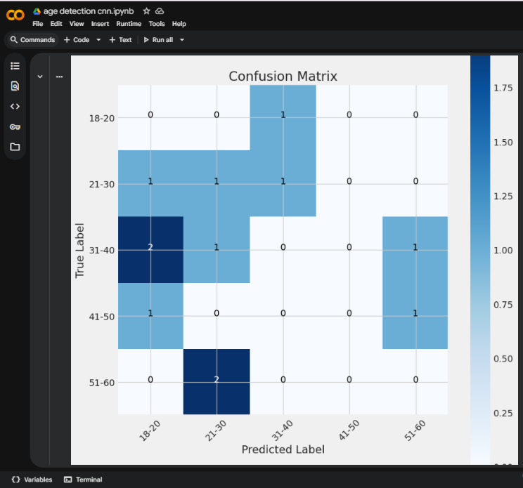

8.2 Training Validation Loss:

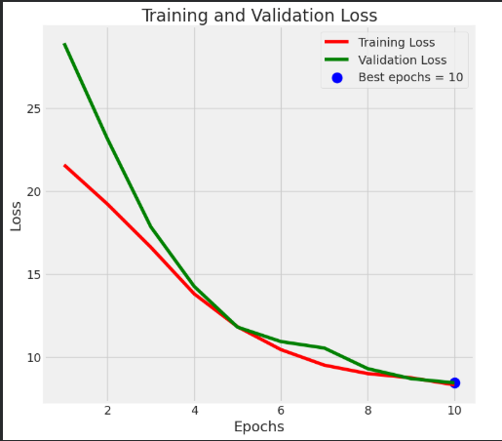

8.3 Training Validation Accuracy:
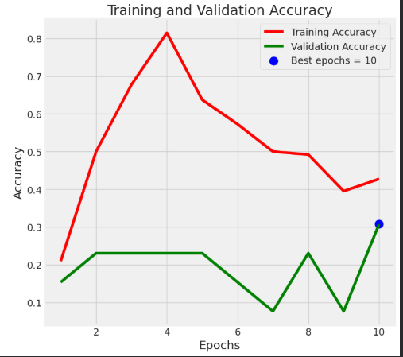

8.4 Result:
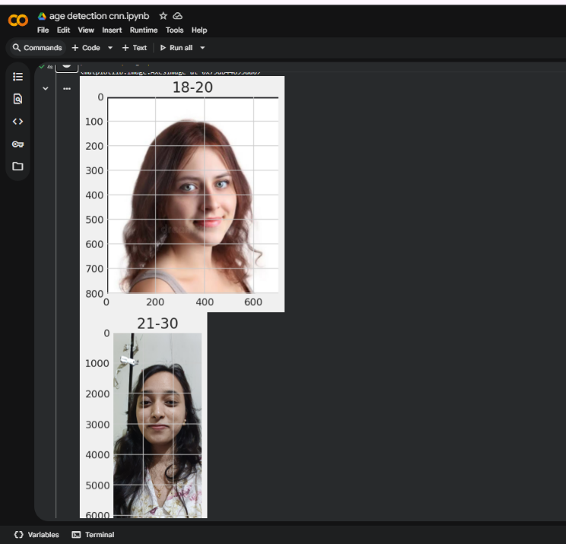
8.4.1 Age classification result

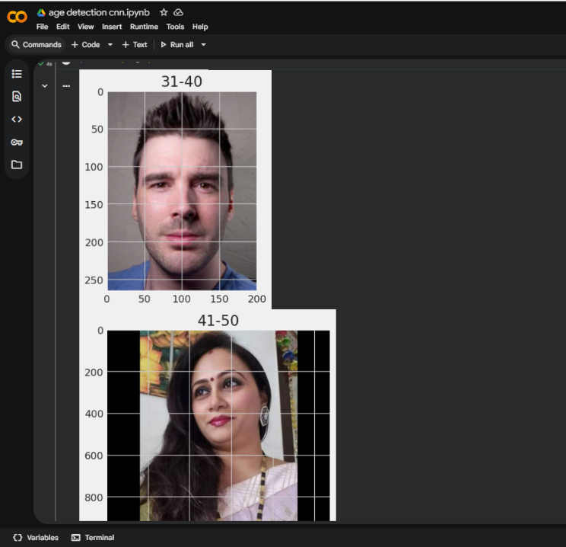

8.4.2 Age classification result

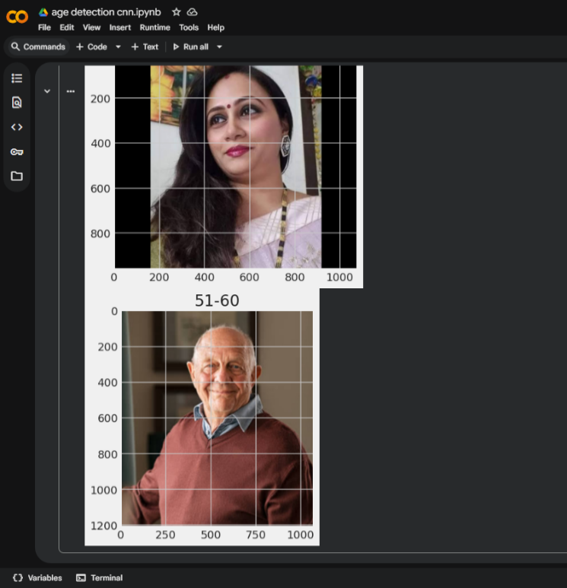
8.4.3 Age classification result

References
[1] Fang fang xing, Zhenyu You, Research on face recognition system based on Computer artificial intelligence technology, 2023 IEEE 3rd International Conference on Electronic Technology, Communication and Information (ICETCI).
[2] Soumaya Zaghbani, Noureddine Boujneh, Med Salim Bouhlel, Age estimation using deep learning, Computers & Electrical Engineering, Volume 68,2018, Pages 337-347.
[3] J, Anandhi & Jain, Alok & Reddy, B. & Divetia, Kanan & Najah Salman Alhilly, Zahraa & Tellapati, Anuradha. (2025). Generative AI-Based Real-Time Face Aging Simulation for Biometric Systems. E3S Web of Conferences. 619. 10.1051.
[4] Yilin Ye, Jianing Hao, Yihan Hou, Zhan Wang, Shishi Xiao, Yuyu Luo, Wei Zeng. Generative AI for Visualization: State of the Art and Future Directions 2024, Cornell Univercity
[5] Erik Brynjolfsson, Danielle Li, Lindsey Raymond, Generative AI at Work, 23 Apr 2023, Cornell University
[6] Jens Peter Andersen, Lise Degn, Rachel Fishberg, Ebbe K. Graversen, Serge P.J.M. Horbach, Evanthia Kalpazidou Schmidt, Jesper W. Schneider, Mads P. Sørensen, Generative Artificial Intelligence (GenAI) in the research process – A survey of researchers’ practices and perceptions, Technology in Society, Volume 81,2025,102813.
[7] Challa, Sai Teja & Jindam, Sowjanya & Reddy, Ruchitha & Uthej, Kalathila. (2021). Age and Gender Prediction using Face Recognition. International Journal of Engineering and Advanced Technology.
[8] Locky Law, Application of generative artificial intelligence (GenAI) in language teaching and learning Elsevier, 2024.
[9]Neha Sharma, Reecha Sharma, Neeru Jindal , Prediction of face age progression with generative adversarial networks, Springer 2022.
[10] Lixiang Li, Xiaohui MU, Siying LI, Haipeng Peng, A Review of Face Recognition Technology, IEEE 2016.
[11] Manisha M. Sawant, Kishor M. Bhurchandi, Age invariant face recognition: a survey on facial aging databases, techniques and effect of aging, Springer 2018.
[12] Khawla Alhanaeea, Mitha Alhammadia, Nahla Almenhalia, Maad Shatnawia, Face Recognition Smart Attendance System using Deep Transfer Learning, ELSEVIER, 2021.

